TASK 10 – MEASURE AND COMPARE

1. Aim
To measure and compare the performance of system calls, process creation and thread creation in a Linux operating system by using suitable C programs and performance measurement tools.

2. Introduction
Performance measurement is an important activity in operating system evaluation. It helps to understand how efficiently an operating system manages CPU resources, memory and processes.
In a smart hospital environment, multiple applications work simultaneously. Patient monitoring systems, medical databases and imaging applications require efficient resource management.
This experiment focuses on measuring the cost of system calls and comparing the execution performance of processes and threads.

3. Objectives
The main objectives of this experiment are:
- To measure system-call overhead using strace.
- To compare different file buffer sizes.
- To measure user-mode and kernel-mode execution time.
- To create and measure 1,000 processes.
- To create and measure 1,000 threads.
- To compare execution time and memory consumption.
- To identify the performance differences between processes and threads.

4. Experimental Environment
The experiment was performed using Kali Linux running inside Oracle VirtualBox on a Windows 11 laptop.
Component | Configuration
Host Operating System | Windows 11
Virtualization Software | Oracle VirtualBox
Guest Operating System | Kali Linux
Compiler | GCC 15.2.0
System Call Tracing Tool | strace 7.2
Performance Measurement Tool | /usr/bin/time
Programming Language | C
Thread Library | POSIX Pthreads

5. System Call Performance Measurement
System calls allow applications to communicate with the operating system kernel.
The strace utility was used to observe and measure the system calls performed by the file-copy program.

Command Used
strace -c ./copy_file

Buffer Size Comparison
The program was executed with three different buffer sizes.
Buffer Size | Successful read() Calls
1 byte | 10,000
512 bytes | 20
4096 bytes | 3

Actual strace Results
The following results were obtained from the whole-program execution:
System Call | Number of Calls | Time (Seconds)
write | 10,029 | 0.053115
read | 10,027 | 0.049691
close | 9 | 0.000788
openat | 9 | 0.000170
unlink | 2 | 0.000053
Total | 20,105 | 0.103822
Observation:
The experiment shows that increasing the buffer size significantly reduces the number of successful read() operations.
A larger buffer allows more data to be transferred in a single system call, reducing the overhead associated with repeated system-call operations.

6. User Mode and Kernel Mode Performance
The Linux time utility was used to measure execution time and memory usage.

Command Used
/usr/bin/time -v ./copy_file

Actual Results
Measurement | Result
User Time | 0.00 seconds
System Time | 0.00 seconds
CPU Utilization | 85%
Elapsed Time | 0:00.00
Maximum Resident Set Size | 1648 KB
Major Page Faults | 0
Minor Page Faults | 81
Exit Status | 0
Observation:
The program completed successfully. The user and system CPU times were rounded to 0.00 seconds because the experiment involved a small file.
The time utility provides information about CPU usage, execution time and memory consumption.

7. Process Creation Performance Measurement
A C program was developed to create 1,000 child processes using the fork() system call.
Each child process terminates using _exit(0), while the parent process waits for its completion using waitpid().

Compilation Command
gcc -Wall -Wextra -O2 process_test.c -o process_test

Execution Command
./process_test

Actual Output
Process Creation Experiment
Total processes created: 1000
Successfully completed: 1000
Total time: 0.312232 seconds
Average time per process: 312.232 microseconds
Parent maximum RSS: 3704 KB

Memory and Time Measurement
Command:
/usr/bin/time -v ./process_test
Actual measurements:
Measurement | Result
Total processes | 1,000
Successfully completed | 1,000
Program execution time | 0.312232 seconds
Time utility elapsed time | 0.33 seconds
Average time per process | 312.232 microseconds
Maximum RSS (time utility) | 1544 KB
User Time | 0.18 seconds
System Time | 0.08 seconds
Exit Status | 0
Observation:
The program successfully created and completed 1,000 processes.
The experiment demonstrates the time and resource overhead involved in process creation and termination.
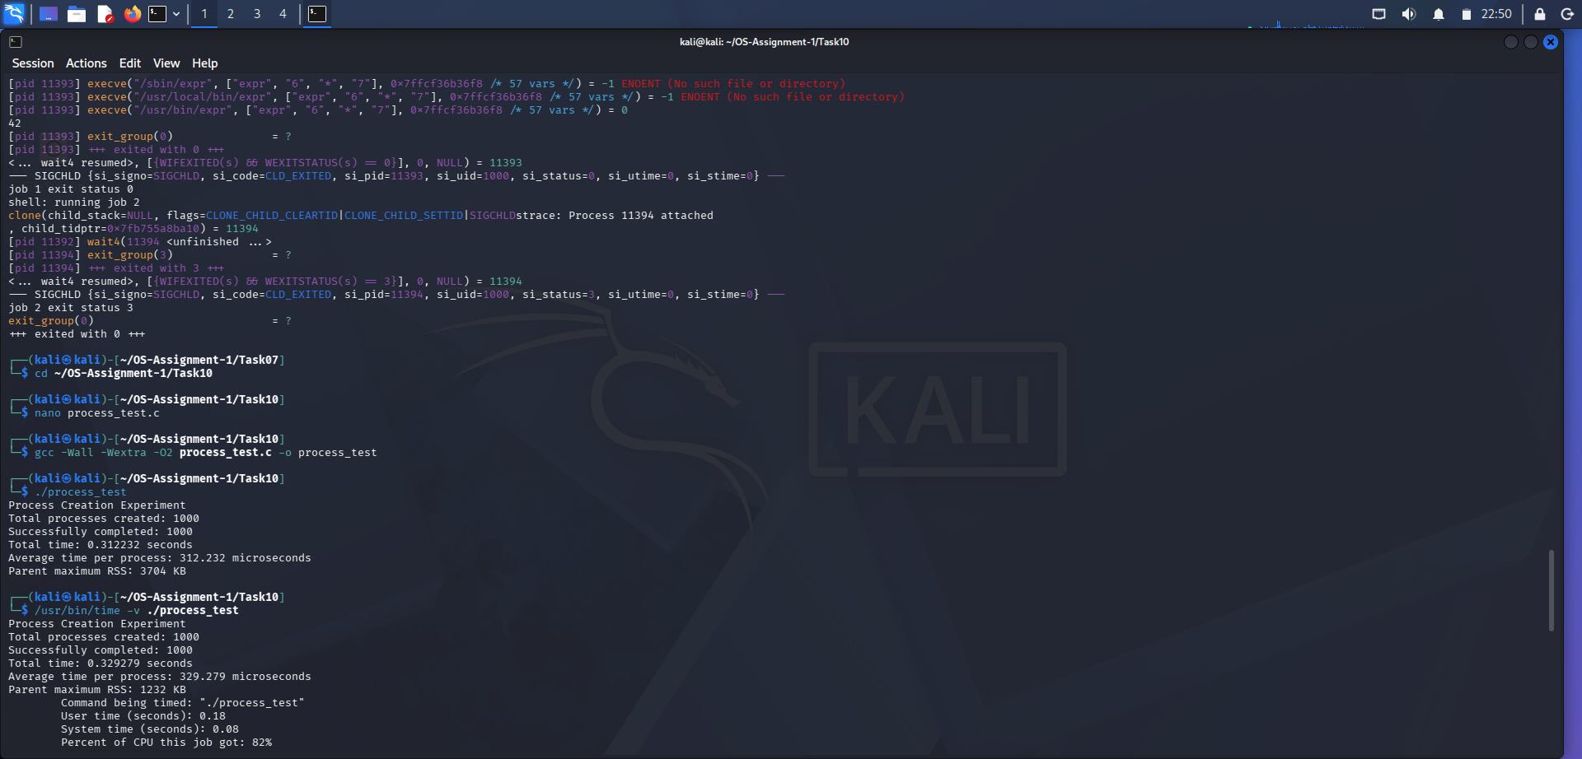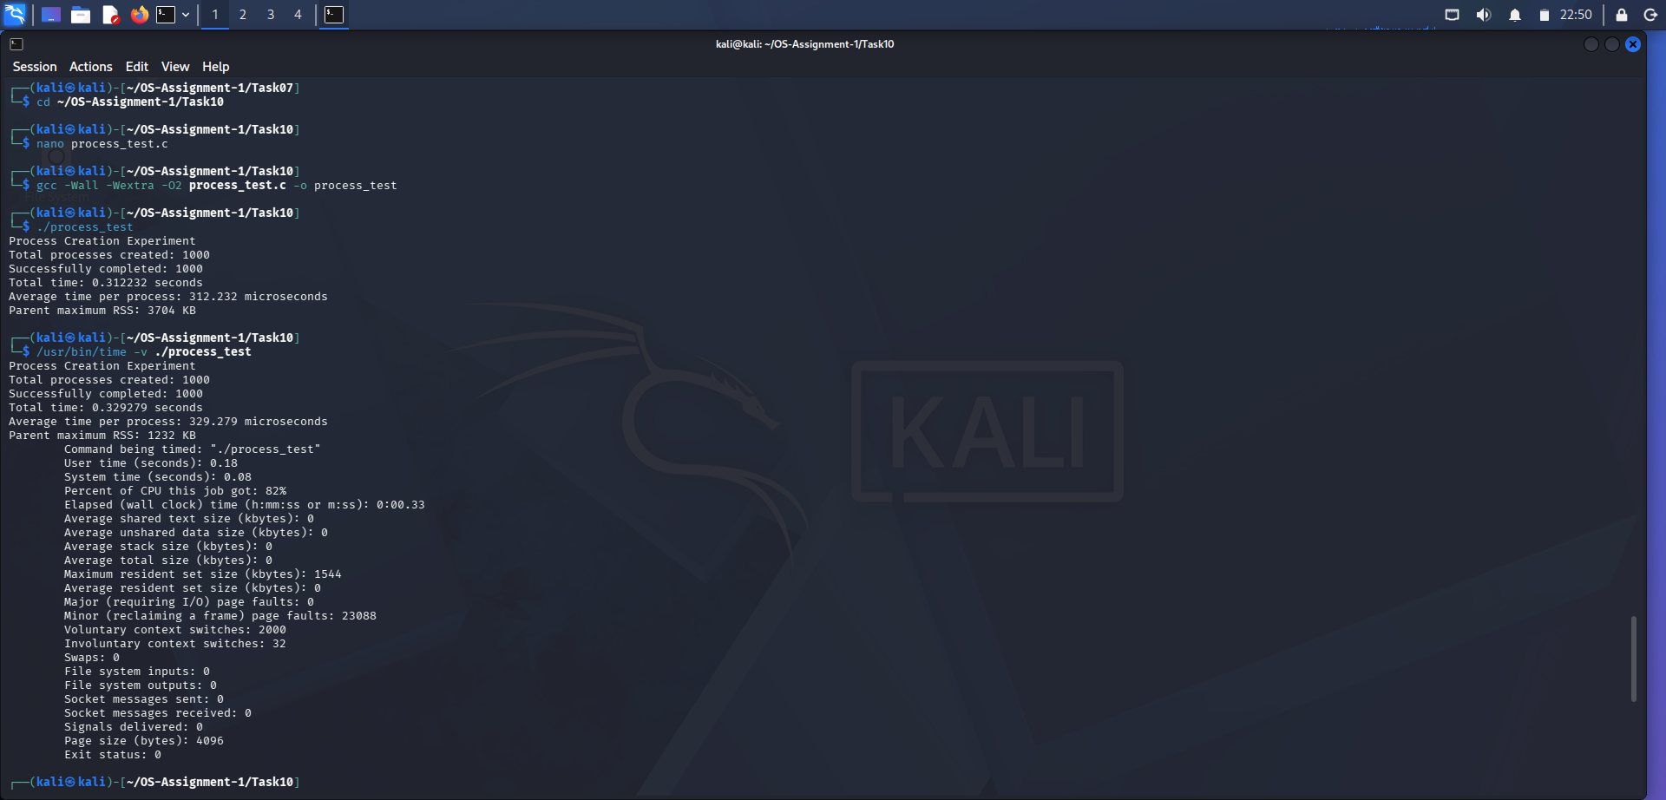

8. Thread Creation Performance Measurement
A C program was developed using the POSIX pthread library to create and complete 1,000 threads.
The pthread_create() function creates a new thread, and pthread_join() waits for its completion.

Compilation Command
gcc -Wall -Wextra -O2 -pthread thread_test.c -o thread_test

Execution Command
./thread_test

Actual Output
Thread Creation Experiment
Total threads created: 1000
Successfully completed: 1000
Stack size per thread: 65536 bytes
Total time: 0.123622 seconds
Average time per thread: 123.622 microseconds
Process maximum RSS: 3704 KB



Memory and Time Measurement
Command:
/usr/bin/time -v ./thread_test
Actual measurements:
Measurement | Result
Total threads | 1,000
Successfully completed | 1,000
Thread stack size | 65,536 bytes
Program execution time | 0.123622 seconds
Time utility elapsed time | 0.10 seconds
Average time per thread | 123.622 microseconds
Maximum RSS (time utility) | 1616 KB
User Time | 0.00 seconds
System Time | 0.07 seconds
Exit Status | 0
Observation:
The program successfully created and completed all 1,000 threads.
The experiment measured the time required for thread creation and completion.
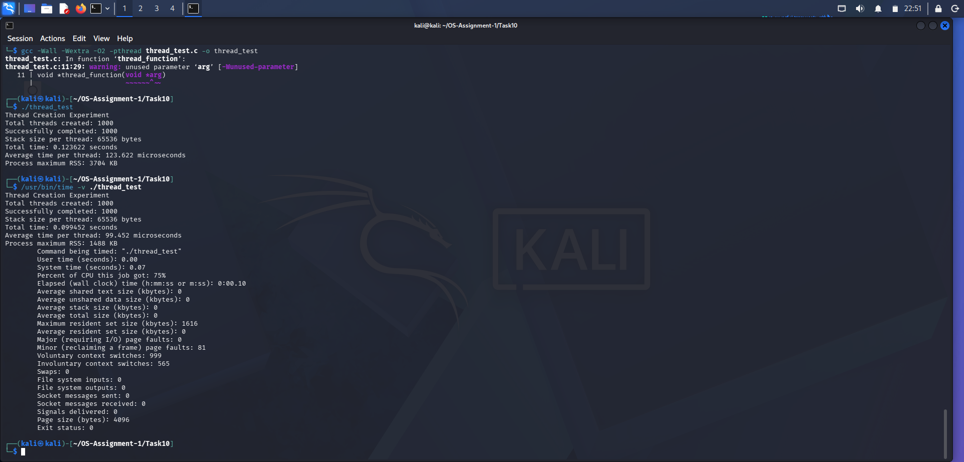

9. Process and Thread Performance Comparison
The following table compares the actual results obtained from both experiments.
Parameter | Process | Thread
Total Count | 1,000 | 1,000
Program Execution Time | 0.312232 s | 0.123622 s
Average Time | 312.232 µs | 123.622 µs
Time Utility Elapsed Time | 0.33 s | 0.10 s
Maximum RSS | 1544 KB | 1616 KB
Exit Status | 0 | 0
Performance Analysis:
The measured program execution time for thread creation was lower than process creation time.
In this experiment, thread creation and completion took approximately 0.123622 seconds, whereas process creation and completion took approximately 0.312232 seconds.
This difference occurs because threads share the address space and other resources of their parent process, while processes have separate virtual address spaces.
The maximum RSS values are peak memory measurements reported by the time utility. They are not the total memory consumption of all child processes or threads.
The results are specific to the tested system and workload.

10. Alternative Concept – Thread Pool
A thread pool is an alternative approach to repeatedly creating new threads.
It maintains a fixed number of worker threads that execute multiple tasks.

Advantages
- Reduces repeated thread creation overhead.
- Improves resource utilization.
- Supports concurrent task execution.
- Reduces thread management overhead.
- Improves application responsiveness.

Applications in Smart Hospitals
Thread pools can be used for processing multiple database requests, handling background tasks and managing non-critical hospital application workloads.

11. Complexity Analysis

A. Process Creation
Creating N processes involves N fork() operations.
The total work increases with the number of processes.

B. Thread Creation
Creating N threads involves N pthread_create() operations and corresponding pthread_join() operations.
Threads generally require fewer resources than independent processes because they share the process address space.

C. Memory Complexity
Processes maintain separate virtual address spaces and process-management information.
Threads share process memory but require individual stacks and thread-management information.
The actual memory consumption depends on the operating system, application and execution environment.

12. Conclusion
The experiment successfully evaluated operating system performance using system-call tracing, execution-time measurement, process creation and thread creation.
The buffer-size comparison demonstrated that larger buffers reduce the number of successful read() system calls.
The process experiment successfully created and completed 1,000 processes in approximately 0.312232 seconds.
The thread experiment successfully created and completed 1,000 threads in approximately 0.123622 seconds.
The results showed that threads required less execution time than processes in this particular experiment.
Therefore, processes are useful when stronger isolation is required, while threads are suitable for concurrent tasks that share resources.

